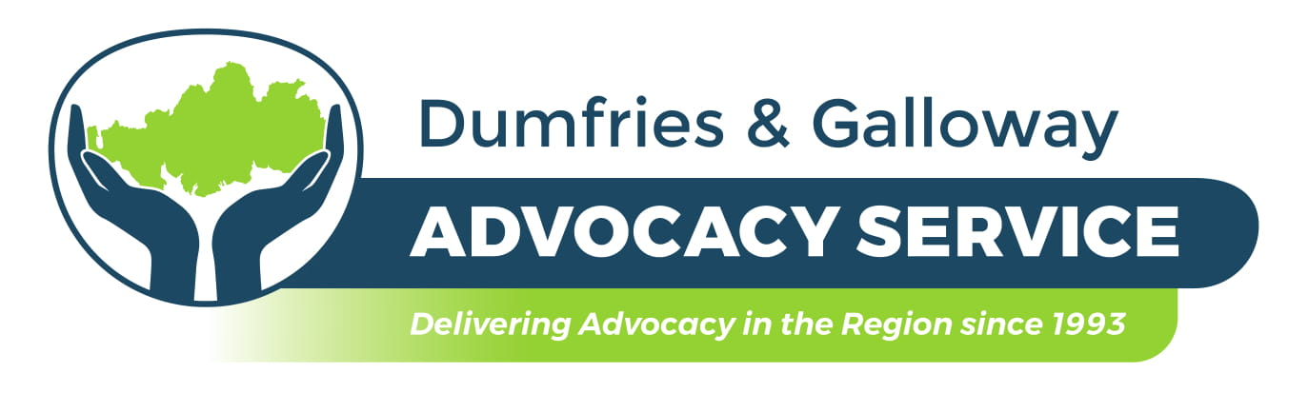

MEMBERSHIP FORM

Name: ________________________________________________________________

Address: _____________________________________________________________

______________________________________________________________________

__________________________________ Post Code:__________________________

Home Telephone: ______________________________________________________

Mobile Number: ________________________________________________________

Email: ________________________________________________________________

I wish to be placed on the register of members of the Dumfries and Galloway Advocacy Service and confirm that I subscribe to the Charitable Objects of the Company.

“The objects of the Company shall be to promote the welfare and relieve the distress, suffering and poverty of those affected by disability, disorder, illness or distress in Dumfries and Galloway in particular, but not exclusively, in any way that is charitable in law. In furtherance thereof, but not otherwise, the Company shall seek to:
a) encourage such persons to involve themselves in all aspects of society and in particular in those decisions affecting themselves, their families and their carers through co-operation and interaction with the statutory authorities and other agencies.
b) provide an advocacy service for such persons.
c) promote, provide, enable and encourage the training and education of people in the field of advocacy so that they may develop the skills to help the aforementioned individuals and groups.
d) promote the understanding and awareness of the rights of the aforementioned individuals, their families, and their carers.

Membership entitles you to be invited to and to attend the general meeting, have a vote at such meetings and where appropriate, stand for election to the Board of Directors. Membership is not accessible to employees of the Company. Membership is subject to the approval of the Board of Directors.

Signed: ___________________________________

Date: _____________________________________

Please see over for agreement to consent for the storage and use of personal information in keeping with the Data Protection / ……

Requirements of Data Protection

- Please note that your data is not shared with anyone outside of Dumfries and Galloway Advocacy Service and is held securely and for 6 years after your membership ceases.

- Please ensure that you let us know about any changes to the information supplied.

- The lawful basis for holding your information is to deliver our services to you in line with the contract we have in place with Dumfries and Galloway Health and Social Care.

- You have the right to complain to the Information Commissioner if you think there is a problem with the way Dumfries and Galloway Advocacy Service is handling your information.

- You have the right to be informed of the information we are keeping about you; the right of access to such information; the right to rectification of any errors in the information; the right to erasure of information and the right to object. We ensure that information that is out of date is deleted appropriately.

- You are entitled to ask to see the personal information we hold, and all reasonable requests will be responded to within one month at no cost.

I consent to my personal information being stored and used as stated above.

Signature: __________________________ Date: ________________________

