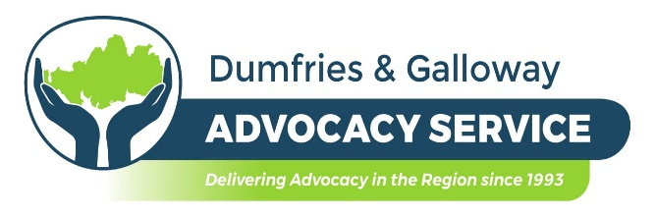

PERSON SPECIFICATION

Job Title: Independent Advocate

The post holder will be expected to have the following experience, skills & knowledge base and personal qualities.

- Experience of and/or understanding of the role of the independent advocate.
- Experience of working with adults at risk of harm or exploitation.
- An awareness of the needs of those affected by mental health problems or mental disorder.
- An understanding of relevant legislation.
- Computer literacy and competence.
- Good communication and listening skills.
- Ability to work on one’s own initiative.
- The capacity to work co-operatively as part of a team.
- It is essential you have a full driving licence and access to independent transport.
- Knowledge of local geography.
- An understanding of the role of statutory services.
- The ability to prioritise.
- Advocacy Skills.
- Literacy.

POST SUMMARY
This post is to provide a staffed resource to meet the advocacy requirements of clients across the spectrum of referrals received by Dumfries and Galloway Advocacy Service. Such referrals include those from all aspects of NHS and Council services, including primary, secondary and tertiary health care, mental health and learning disability clients, housing, child & adult protection, domestic abuse and drug and alcohol service issues. We also receive many self-referrals and requests for support from carers and other third sector organisations.

The post holder will therefore have to be able to travel independently across the region for which expenses are paid. The post holder is NOT required to transport clients.

POST FUNDING
Dumfries and Galloway Advocacy Service is funded by NHS D&G and D&G Council to provide Individual and Collective Advocacy for all adults who may be at risk in Dumfries and Galloway, including under the terms of the Mental Health (Care & Treatment) (Scotland) Act 2003. This post is funded from these contracts.

Closing Date: 11th March 2022

