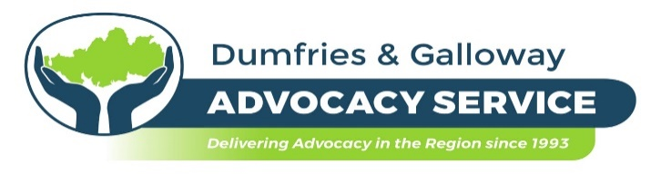

JOB SPECIFICATION

Job Title Independent Advocate

Job Purpose To provide independent one to one and collective advocacy across all referral groups in Dumfries and Galloway.

Responsible to Chief Executive and Service Manager

Base Our Independent Advocates have been working from home during the pandemic. This will be reviewed within the next 3 – 6 months; one possible scenario is that we move to a combination of office/home/remote working, so candidates will need to be flexible in their approach to working location.

Hours 21 hours per week over 3 days (Wed-Fri preferred)

Annual Leave 27 days per annum plus 9 statutory days (pro-rata)

Starting Salary (£20,566 pro-rata) £12,339

Duration This post is initially offered for a period of one year but we are hopeful (and currently anticipate) that funding will continue longer term.

MAIN JOB PURPOSE
To provide independent one to one and collective advocacy to all referrals to Dumfries and Galloway Advocacy Service, i.e. referrals that may have requirements under general, specific or mental health act contexts. The advocate’s role is to empower clients to express their views, wishes and choices; you will ensure that clients remain as involved as possible in all decisions that affect their lives.

MAIN TASKS
- To maintain and manage a personal case load.
- To work on one’s own and as part of a team.
- To attend staff, team, supervision and training sessions as directed.
- To maintain accurate administrative records of all case work
- To work supportively, where appropriate, with volunteer advocates.
- To work in accordance with SIAA Principles, Standards and Code of Best Practice, Dumfries and Galloway Advocacy Service Contractual arrangements, Policies and Procedures and the Law.
- To promote and raise awareness of the service.
- To carry out any other task reasonably requested to ensure the efficient running of the Company.

Closing Date: 11th March 2022

