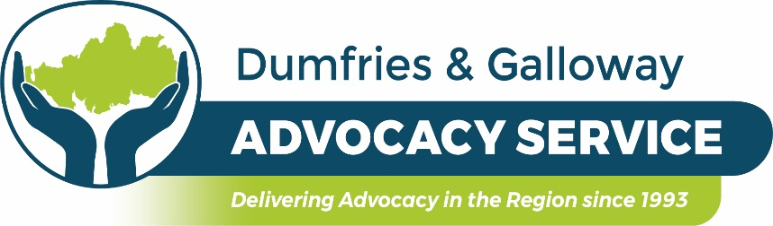

Volunteer Advocate Role Description

Title: Volunteer Independent Advocate

Location: Dumfries and Galloway

Salary: No salary but reasonable out of pocket expenses will be paid

Hours: As available and/or as required by client

Responsible to: Chief Executive

Age: You must be 18 years or over

Main Purpose of Role

To work in partnership with clients, to empower and enable them to be heard so that they take as much control of their situation as is possible.

You must be able to commit to the service for a minimum of one year.

What’s in it for you?

You will receive training on independent advocacy, learning disability, the mental health (care & treatment) (Scotland) act 2003, adult support and protection as well as listening and communication skills and much more. You will be mentored and have access to peer support and supervision. The skills you will learn are transferrable and could be added to your CV to help with any future employment, and if required we can also support you with a reference after a period of time of working with clients.

You will make a difference to other people’s lives; develop new skills and meet new people and you will work alongside a small friendly team.

About us

Dumfries and Galloway Advocacy Service supports adults aged 18 and over with:

We are commissioned to deliver the following services –

- Adult Individual Independent Advocacy (Aged 18 and over)
- Adult Collective / Group Independent Advocacy (Aged 18 and over)
The aim of the adult individual independent advocacy is –

- to promote empowerment of adult residents of Dumfries and Galloway who require help, in whatever context, to understand the options open to them, to enable them to make informed choices and/or to make their own views known.

The aim of collective/group independent advocacy is –

- to promote empowerment of adult residents of Dumfries and Galloway where a group of people who are all facing a common problem get together on a formal basis to support each other over specific issues. Individual members of the group may also support each other over specific issues. The group may campaign on an issue that affects them all. Being part of a collective advocacy group can help to reduce a person’s sense of isolation when raising a difficult issue.

Key Duties Include

- Listen to the client’s concerns and story
- Empower and enable the client to achieve as close to their preferred outcome as possible by:
- Providing information
- Defining options and choices to be taken which are based on information

- Support the client through any procedures which may be necessary
- Drafting / Writing letters
- Attending meetings
- Research

- Report to your line manager on the progress of client work or any problems.
- Keep an electronic accurate record of all meetings and communications involved in a client’s case.
- Keep the client fully informed of the progress of their case and all information involved.
- Attend and participate in support, supervision and appraisal meetings.
- Attend ongoing training.
- Liaising with professionals from other organisations.

You must have the ability to:

Listen

Empathise

Empower

Enable

Be non-directive and non-judgmental

Deal with emotive and distressing issues

Keep confidences (organisational exceptions) and boundaries

Express yourself clearly in verbal / written form

Work as part of a team and on one’s own

Be able to use email, word etc and carry out work electronically.

Please Note: Our Volunteers are required to carry out administrative client work from home using their own equipment –

You must have access to:

a laptop or computer

the internet

a landline or mobile phone

Do you have access to transport?

Please Note: There are no minimum hours per week expected of our volunteers however, we ask that you are as flexible as possible to be able to cover client meetings and also that you sign up to volunteer to our service for a minimum of one year. This is due to the time taken through training, shadowing and mentoring.

If you would like further information about this volunteer role or wish to apply, please contact Pamela Deans, Chief Executive on 01387 247237 or email: pamela.deans@dgadvocacy.co.uk

