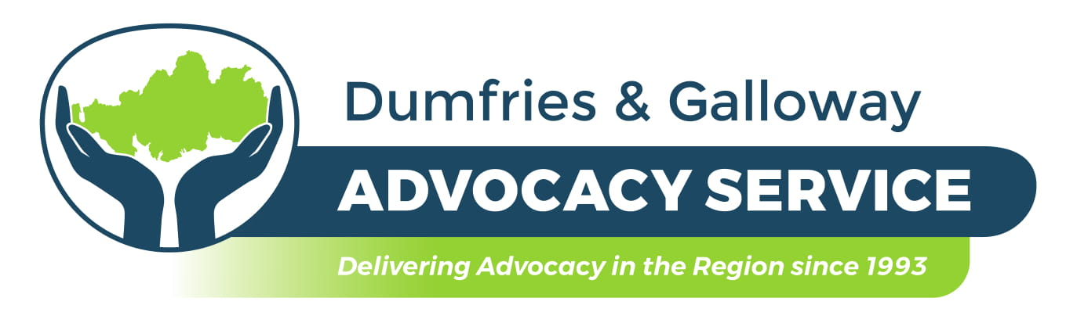
What is it?
Independent Advocacy is about empowering people who are involved in using or receiving services. We work within Dumfries & Galloway to express our client’s views, wishes and feelings. We are as free from conflict of interest as possible and work separately from other services; our actions are not influenced by the views of service providers. We are a registered charity with a Board of Directors. We follow the Code of Conduct and Principles & Standards as published by the (SIAA) Scottish Independent Advocacy Alliance.

What do advocates do?

Advocates strive at all times to stand by the client and minimise conflict of interest. Independent Advocacy is often most relevant where a conflict of interest has arisen in the management of a person’s care and treatment, and the advocate can ensure that the client’s voice is expressed without compromise. An advocate works on a one to one basis with the client to find solutions to their issues and help them to understand the options that are available to them, while protecting their rights and ensuring they are treated with respect and dignity. This service may also provide support to those individuals within a carer’s role.

Why is independent advocacy important?

Dumfries and Galloway Advocacy Service will help a client understand what might be happening in their life and take control of their circumstances by empowering them to help themselves. They will use listening skills and help a client think through their problems or find information that will help them make informed choices and decisions. Advocates can also speak on a client’s behalf if they feel unable to do so, making sure their thoughts, feelings and wishes are fully understood by others, but also make sure they understand what may be said to them or about them.

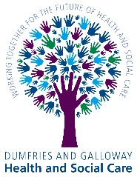
Who are we?

Dumfries and Galloway Advocacy Service are commissioned on behalf of Dumfries and Galloway Health and Social Care to deliver services that are free, confidential and person centred. Although we are a confidential service it may be necessary to disclose information to a third party if we believe the client, another person or child is at risk of harm.

Dumfries and Galloway Advocacy Service supports adults aged 18 and over with:

- Individual General issues around Local Authority, Social Services, NHS, GP’s and much more…
The aim is to promote empowerment of adult residents of Dumfries and Galloway who require help, in whatever context, to understand the options open to them, to enable them to make informed choices and/or to make their own views known.

- Adult Advocacy in terms of the Mental Health (Care & Treatment) (Scotland) Act 2003:
The aim is as above, plus: to provide independent advocacy to people with a mental disorder in accordance with the requirements of the Mental Health Act, enabling people to be empowered and their views heard.

- Collective Advocacy
The aim is to promote empowerment of adult residents of Dumfries and Galloway where a group of people who are all facing a common problem get together on a formal basis to support each other over specific issues. Individual members of the group may also support each other over specific issues. The group may campaign on an issue that affects them all. Being part of a collective advocacy group can help to reduce a person’s sense of isolation when raising a difficult issue.

Legislation (The Law)

If an adult or a young person is subject to intervention under the Mental Health (Care & Treatment) (Scotland) Act 2003, they have a right to independent advocacy services and a referral will be made by the Mental Health Officer (MHO) to the relevant advocacy service.
Clients who come under the Mental Health (Care & Treatment) (Scotland) Act 2003 can also refer themselves to our service for advocacy support relating to issues such as hospital detention, mental health tribunal and issues relating to the NHS or Social Services and more.

Under the Adult Support & Protection (Scotland) Act 2007 which offers support to persons aged 16 or over, there is a right to be made aware of the role of advocacy services in assisting with a clearer understanding of the person’s wishes and feelings.

Further Information

We are an issue based service, and as such, once the clients issue is finished we will contact them and/or their referrer about closing the case and if they have any further issues in the future they can come back to us at any time.

We are not able to support clients with Employment Issues or give Benefits Advice and we do not attend Employment or Benefit Tribunals / Assessments. We are also not able to support a client, or speak on behalf of a client to the Media.

Situations Dumfries and Galloway Advocacy Service provide support for:
- NHS and Local Authority  - Mental Health issues including Tribunals  - Adult Support and Protection  - Older persons issues  - Child Protection, Children’s Hearings, Reviews | - Adults with Incapacity  - Learning Disability  - Acquired Brain Injury  - Carers Issues  - Autistic Spectrum / Asperger’s Syndrome
Service Objectives
- To provide access to an advocacy service for all people regardless of location, age, gender, disability, sexual orientation, ethnic origin, faith/religion, or social background.
- To match clients and advocates appropriate to each situation’s needs, seeking specialist support where indicated and ensuring clients’ comfort at all times.
- To support people who, because of incapacity or communication difficulties, may not be able to express their needs or views.
- To guide people towards self-advocacy and avoid creation of dependency.
- To help clients to access and understand information relevant to them and make appropriate choices or decisions which give them fuller control of their lives.
- To develop links with service providers, professionals and relevant support organisations to ensure clear understanding of the role of advocacy.
- To provide access to advocacy in line with the prevailing legislation and Scottish Government guidance.
How do you refer to our service?
Any person can refer from any agency whether Health, Social Work, Third Sector etc. but the client must be aware of and be able to consent to the referral unless they lack capacity and it is then the responsibility of the referring agency to make the referral. Clients can also self-refer.

