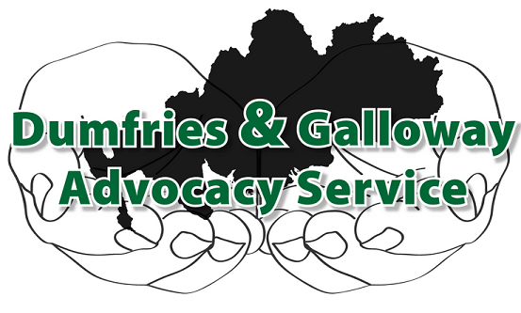

**JOB SPECIFICATION**

**Job Title** Independent Advocate **(Job Reference IA02)**

**Job Purpose** To provide independent one to one and collective advocacy across all “community of interest” referral groups in Dumfries and Galloway.

**Responsible to** Chief Executive

**Base**  9 Church Crescent, Dumfries

**Hours** 21 hours per week(Tuesday, Thursday, Friday)

**Annual Leave** 27 days per annum plus 8 statutory days (pro rata)

**Salary** (£16,873 pro rata) £9,576 (above the Real Living Wage)

**Duration** One Year

**MAIN JOB PURPOSE**

To provide independent one to one and collective advocacy to all “community of interest” referrals to Dumfries and Galloway Advocacy Service, “Community of Interest” refers to referrals that may have requirements under general, specific or mental health act contexts. The advocate’s role is to empower clients to express their views, wishes and choices; you will ensure that clients remain as involved as possible in all decisions that affect their lives.

**MAIN TASKS**

* To maintain and manage a personal case load.
* To work on one’s own and as part of a team.
* To attend staff, team, supervision and training sessions as directed.
* To maintain accurate administrative records of all case work and communicate such records to the main office regularly.
* To co-ordinate all referrals with the Assistant to the CEO and Service Co-ordinator.
* To work supportively, where appropriate, with volunteer advocates.
* To work in accordance with SIAA Principles and Standards and Code of Practice, Dumfries and Galloway Advocacy Service Contractual arrangements, Policies and Procedures and the Law.
* To promote and raise awareness of the service.
* To carry out any other task reasonably requested to ensure the efficient running of the Company.

**PERSONAL SPECIFICATIONS**

The post holder will be expected to have the following experience, skills & knowledge base and personal qualities.

* Experience of and/or understanding of the role of the independent advocate.
* Experience of working with adults at risk of harm or exploitation.
* An awareness of the needs of those affected by mental health problems or mental disorder.
* An understanding of relevant legislation.
* Computer literacy and competence.
* Good communication and listening skills.
* Ability to work on one’s own initiative.
* The capacity to work co-operatively as part of a team.
* It is essential you have a full driving licence and access to independent transport.
* Knowledge of local geography.
* An understanding of the role of statutory services.
* The ability to prioritise.
* Advocacy Skills.
* Literacy.

**POST SUMMARY**

This post is to provide a staffed resource to meet the advocacy requirements of clients across the spectrum of referrals received by Dumfries and Galloway Advocacy Service. Such referrals include those from all aspects of NHS and Council services, including primary, secondary and tertiary health care, mental health and learning disability clients, housing, child & adult protection, domestic abuse and drug and alcohol service issues. We also receive many self-referrals and requests for support from carers and other third sector organisations.

The post holder will therefore have to be able to travel independently across the region for which expenses are paid. The post holder is NOT required to transport clients.

**POST FUNDING**

Dumfries and Galloway Advocacy Service is funded by Joint Commissioning of D&G NHS and Council to provide Individual and Collective Advocacy for all adults who may be at risk in Dumfries and Galloway, including under the terms of the Mental Health (Care & Treatment) (Scotland) Act 2003. This post is funded from these contracts.

To Apply for this post, please go to: [www.dgadvocacy.co.uk/paid-vacancies](http://www.dgadvocacy.co.uk/paid-vacancies)

Closing Date for this post is end of business on Friday 27 April 2018.

*Reviewed April 2018*