DUMFRIES AND GALLOWAY ADVOCACY SERVICE

Easy Read Human Rights
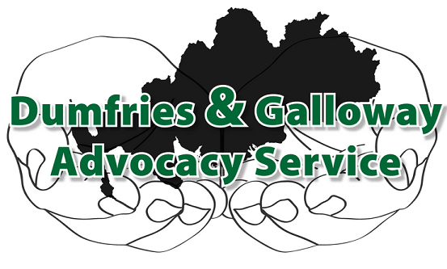

9 Church Crescent
Dumfries
DG1 1DF

Telephone: 01387 247 237
Scottish Charity No: 036075 Limited Company No: 275168
When you use our service we will work to protect your Human Rights under the Human Rights Act 1998.
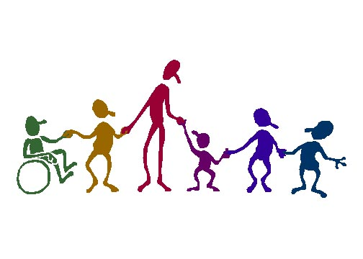
Everyone is protected by these rights and no-one can take them away from us.

No-one can put your life at risk.
No-one can hurt you or punish you.

No-one can frighten you.

No-one can make you a slave or force you to do something you don’t want to.
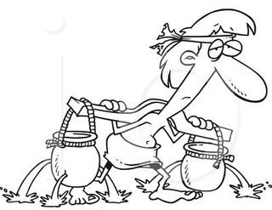

We can live free and safe.

The law is the same for everyone so it must treat us fairly and equally.
No-one can put us in prison without a good reason.
No-one can send us away from our country.

Everyone should respect who we are and not judge us for who we are attracted to (Lesbian, Gay, Bisexual, Transgender or straight). We should not be judged because of our gender (Male, Female, Transgender).
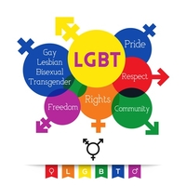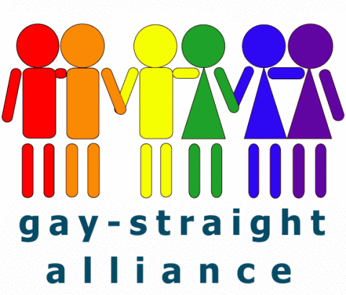

No-one can take us away from our family or someone we are close to.
We have the right to have a home.

We have the right to own things. No-one should take these from us.

We can believe whatever we like.

We can have a religion and change it if we want.

We can share our thoughts and opinions with others.

We must be careful not to say anything untrue about someone else or cause harm or distress to others.
We can protest peacefully, march and hold meetings in public.

We have the right to marry. This includes marrying a person who is the opposite sex to us, the same sex to us and transsexuals (people who have changed from male to female or female to male).
No-one should tell us that we cannot enjoy these rights and freedoms. They belong to everyone.

We have a right to education.

We can vote to decide who is the leader of our country.
We should know our rights, so that we can protect them, and treat others the same as we want to be treated, after all these rights belong to them too.
If you would like to know more about your human rights, you can watch these short videos at:
http://www.humanrights.com/what-are-human-rights/
http://www.youtube.com/watch?v=pRGhrYmUjU4&feature=youtu.be

For the complete version of the Human Rights Act 1998 go to:
http://www.legislation.gov.uk/ukpga/1998/42

You can call our office and ask to speak to an advocate:
01387 247237
You can come to one of our offices and ask for an advocate:

Dumfries Office:

9 Church Crescent
Dumfries
DG1 1DF

Our office is open:
Monday – Friday 9.30am – 3.30pm

(Closed for lunch: 12.30pm – 1.00pm)

Stranraer Office:

Cromarty House
Sun Street
Stranraer
DG9 7JL

(By Appointment Only)
(Tel: 01387 247237)

You can send an e-mail to ask for an advocate:
info@dgadvocacy.co.uk

We have a website that you can look at to find out more about us: www.dgadvocacy.co.uk

ADVOCACY – Defending Your Right to be Heard

Scottish Charity: SC036075 Limited Company: 275168

