DUMFRIES AND GALLOWAY ADVOCACY SERVICE

Easy Read Guardianship Order

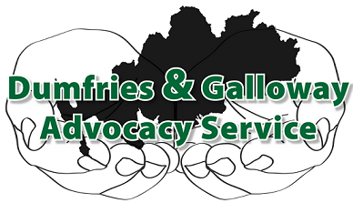

9 Church Crescent
Dumfries
DG1 1DF

Telephone: 01387 247 237

Scottish Charity No: 036075 Limited Company No: 275168

While you were a child, an adult helped you and made decisions for you.
Decisions like; to decide what clothes you wear so that you don’t get too hot or too cold.
To open your mail, read it and respond to it.

To take you on holiday or for day trips.
To decide what food you should eat and cook it for you.
To decide where you should live.

All in the hope of keeping you safe.
When you turn 16 years of age, you become an adult.
So other adults cannot make decisions for you. You make your own decisions.
If another adult wants to continue helping you and making decisions for you, then they need to apply to be your Guardian.
So, they can decide what clothes you should wear, open your mail, cook your meals.

A Guardianship is made to fit your needs. So there could be other things the Guardian wants to help you with that are not mentioned here.
You might not like the idea of someone being your Guardian.
Or you might think this is a great idea.
Or you might not fully understand what it means.
Advocacy can help with this.
An advocate can talk to you about what a Guardian wants to decide for you, and help you to understand it, and how it will affect your life.

Once you understand what the guardianship means, your advocate will ask what you think about it.
For example, you might like having help to cook meals.
but you do not need someone deciding what clothes you wear.
Or you do not agree with any part of it and do not want a guardian at all.
The guardianship is decided by a Sheriff at court.
Your advocate will show you a list of solicitors so that you can have legal representation at court if you wish.
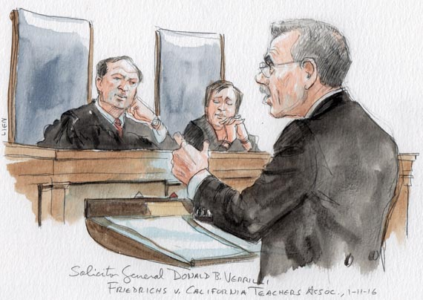
Your advocate can tell the Sheriff what your thoughts are on the guardianship.
If you have a solicitor, they can argue your case.
You can go to court with your advocate to give the Sheriff your views.
Your advocate can speak on your behalf.
You do not have to go to court if you would prefer not to.
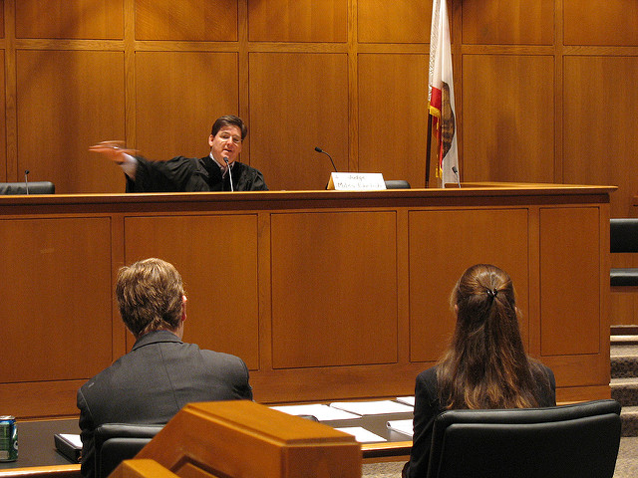
Our service is free, you will not be asked to pay any money.
You can speak to an advocate in private. We respect confidentiality.
You can call our office and ask to speak to an advocate:
01387 247237
You can come to one of our offices and ask for an advocate:

Dumfries Office:

9 Church Crescent
Dumfries
DG1 1DF

Our office is open:
Monday – Friday 9.30am – 3.30pm

(Closed for lunch: 12.30pm – 1.00pm)

Stranraer Office:

Cromarty House
Sun Street
Stranraer
DG9 7JL

(By Appointment Only)
(Tel: 01387 247237)

You can send an e-mail to ask for an advocate:
info@dgadvocacy.co.uk
We have a website that you can look at to find out more about us: www.dgadvocacy.co.uk
ADVOCACY – Defending Your Right to be Heard
Scottish Charity: SC036075 Limited Company: 275168

