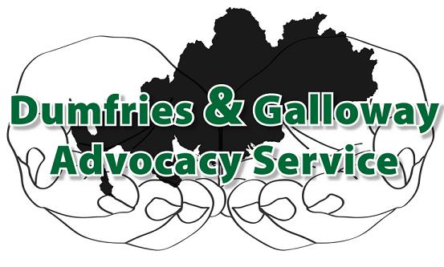

Comments and Feedback
It is the policy of Dumfries and Galloway Advocacy Service to welcome and encourage comments and feedback from people who use our service and agencies that refer people to our service. Comments and feedback, positive and negative, however formal or informal, assist us in monitoring, evaluating and improving our service at all levels.

Complaints Policy

Dumfries and Galloway Advocacy Service strives at all times to provide an efficient, fair, professional, courteous and helpful service to all our clients and others with whom we have dealings, whether they are individuals or organisations. However, if you believe that things have gone wrong, or that you have not received the service or treatment to which you are entitled, we want you to tell us. We can then try to resolve your complaint, and make sure that our practice improves so that it does not happen again. This paper tells you how to make a complaint about the service we provide.

Every attempt will be made by both parties to bring any complaints to an early resolution informally, before applying the formal procedure.

How to make a complaint

You may be able to resolve your complaint by taking it up immediately with the person with whom you have been dealing directly, or with their line manager. This may be done in writing or in any other way that is convenient for you. A written record will be made of the complaint and how it was resolved by the person with whom you have been dealing, and you will receive a copy of that record. If a written record is not convenient for you then the record will be provided for you in a form that is accessible to you.

What Next?

If you cannot resolve your complaint through the above process, then you can formally complain directly to the Chief Executive. Though it is preferred that such a complaint is made in writing, we understand that not all clients are able to do so, and we will receive complaints in other forms where appropriate. You should include in your complaint the following details;
- Your name and address
- Details about what has gone wrong or has not been handled properly
- Copies of any correspondence or documentation about your complaint
- Any indication of how you would like us to resolve your complaint.

If you are not comfortable with making your complaint to the Chief Executive you can make it directly to the Board of Directors, who will appoint a Director to deal with your complaint.

How will your complaint be dealt with?

We will acknowledge your complaint within 5 working days of receipt.
We will try to give you a written response within 20 working days of receipt. If this is not possible we will write to you explaining why we cannot give you a full response and when we can reasonably expect to. We recognise that every complaint is different and circumstances might require more time to be spent on an individual complaint. A formal response will be issued as soon as possible.

What if you are still not satisfied?

If you are not satisfied with the way your complaint has been resolved you may appeal within 5 working days of receiving our response directly to a nominated member of the Board, who will provide you with a full response within 15 working days.

What about Confidentiality?

Confidentiality is a vital part of our Complaints Procedure, and will apply at all stages of the process. Information will only be made available to those directly involved in the complaint and its resolution. Making a complaint will not prejudice your right to continue receiving a service from us.

You will have the right to access all relevant records pertaining to your complaint, except where that information contains identifiable information relating to third parties. Identifiable information is that which identifies personal details of an individual (eg address, health issues, etc).

A Register of Complaints will be kept, the details of which will be made available to the Board of Directors.

Who to Complain to: The Chief Executive, Dumfries and Galloway Advocacy Service, 9 Church Crescent, Dumfries, DG1 1DF

If making a formal complaint, please mark your correspondence ‘Addressee only’.

This policy in no way affects your statutory rights.

9 Church Crescent, Dumfries, DG1 1DF
www.dgadvocacy.co.uk
Scottish Charity: SCO36075 Limited Company: 275168

